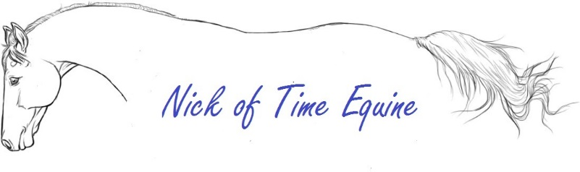 | Date of Coggins  Proof of Rabies  Total Paid $  Check or Cash
ENTRY FORM

Horse Name: ___________________________________ Height: ________ Sex: ______ Age: ______ Color: _________

Rider Name: __________________________________________________________ Age:__________

Rider Address: _____________________________ City: __________________ State: _________ Zip Code: __________

Phone Number: ____________________________________ Email: _________________________________________
~~~~~~~~~~~~~~~~~~~~~~~~~~~~~~~~~~~~~~~~~~~~~~~~~~~~~~~~~~~~~~~~~~~~~~~~~~~~~~~~~~~~~~~~~~~~~~~~~~~~~~~~~~~~~~~~~~~~~~~~~~~~~~

Trainer Name: _____________________________________________________________

Trainer Address: _____________________________ City: __________________ State: _________ Zip Code: __________

Phone Number: ____________________________________ Email: _________________________________________
~~~~~~~~~~~~~~~~~~~~~~~~~~~~~~~~~~~~~~~~~~~~~~~~~~~~~~~~~~~~~~~~~~~~~~~~~~~~~~~~~~~~~~~~~~~~~~~~~~~~~~~~~~~~~~~~~~~~~~~~~~~~~~
Classes Entered (Please Circle):
1 2 3 4 5 6 7 8 9 10 11 12 13 14 15 16 17 18 19 20 21 22 23 24 25 26 27 28 29 30 31 32 33 34 35 36 37 38 39 40 41 42 43
Number of classes: _______ x Pre Entry Fee $7.50 = $ ___________ Show Fee $7.00
Number of classes: ______ x Entry Fee $10.00 = $ _____________ Total: $_______________
~~~~~~~~~~~~~~~~~~~~~~~~~~~~~~~~~~~~~~~~~~~~~~~~~~~~~~~~~~~~~~~~~~~~~~~~~~~~~~~~~~~~~~~~~~~~~~~~~~~~~~~~~~~~~~~~~~~~~~~~~~~~~~
Entry Agreement, Release and Assumption of Risk
Proof of Coggins required. I agree that all entries are made at my own risk and further agree to indemnify and hold harmless Nick of Time Equine, Riverbank Farm and its agents, representatives and employees from any and all liabilities arising out of my participation as an exhibitor or the participation of any person riding, exhibiting or arising our of any vehicle or animal which I may send to this show. Upon entering the premises of Nick of Time Equine and Riverbank Farm, I assume all responsibility for any injury and/or damage done by any vehicle or animal which I may send to this show. My signature below indicates that I have read and understood, accept and freely sign this agreement which shall take effect as a sealed instrument.

____________________________________________ ________________________________________
Print Name Signed (parent or legal guardian if under 18)

____________________________________________ __________________________________________
Trainer Signature Date

