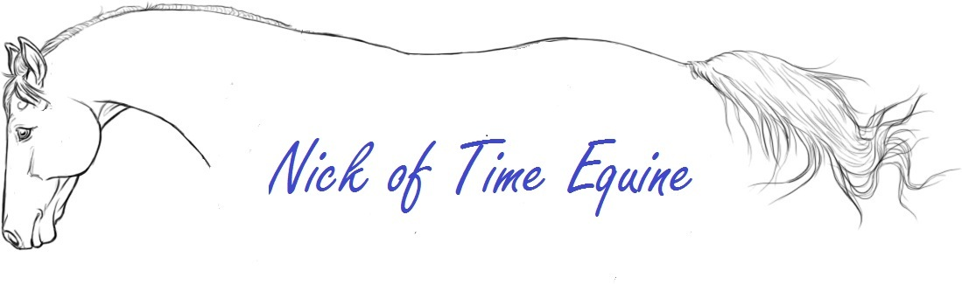
Laundry Services
413-770-7532
laundry@nickoftimeequine.com

Name: ____________________________________________
Address: ____________________________________________
Phone number: ______________________________________
Email: ______________________________________________

Type of Laundry | Quantity | Brief Description
Waterproof Rain Sheet
Waterproof Med. Weight
(100-250grams of fill)
Waterproof Heavy Weight
(260+ grams of fill)
Stable Sheet
Stable Blanket
(100-250grams of fill)
Stable Blanket
(260+ grams of fill)
Fleece coolers/Irish knits
Fly sheets/Scrims
English Saddle Pad/Navaho Pad
Bulk Laundry (towels, wraps, etc.)

Special Instructions: ________________________________________________
Rush Job: Yes_____ No______

